For this homework we had to encode our name in morse code and use the watch dog timer interrupt to trigger a service routine that would both allow us to blink our name and also control which LED the message came out of.

For this assignment I made an array of values that is my message. 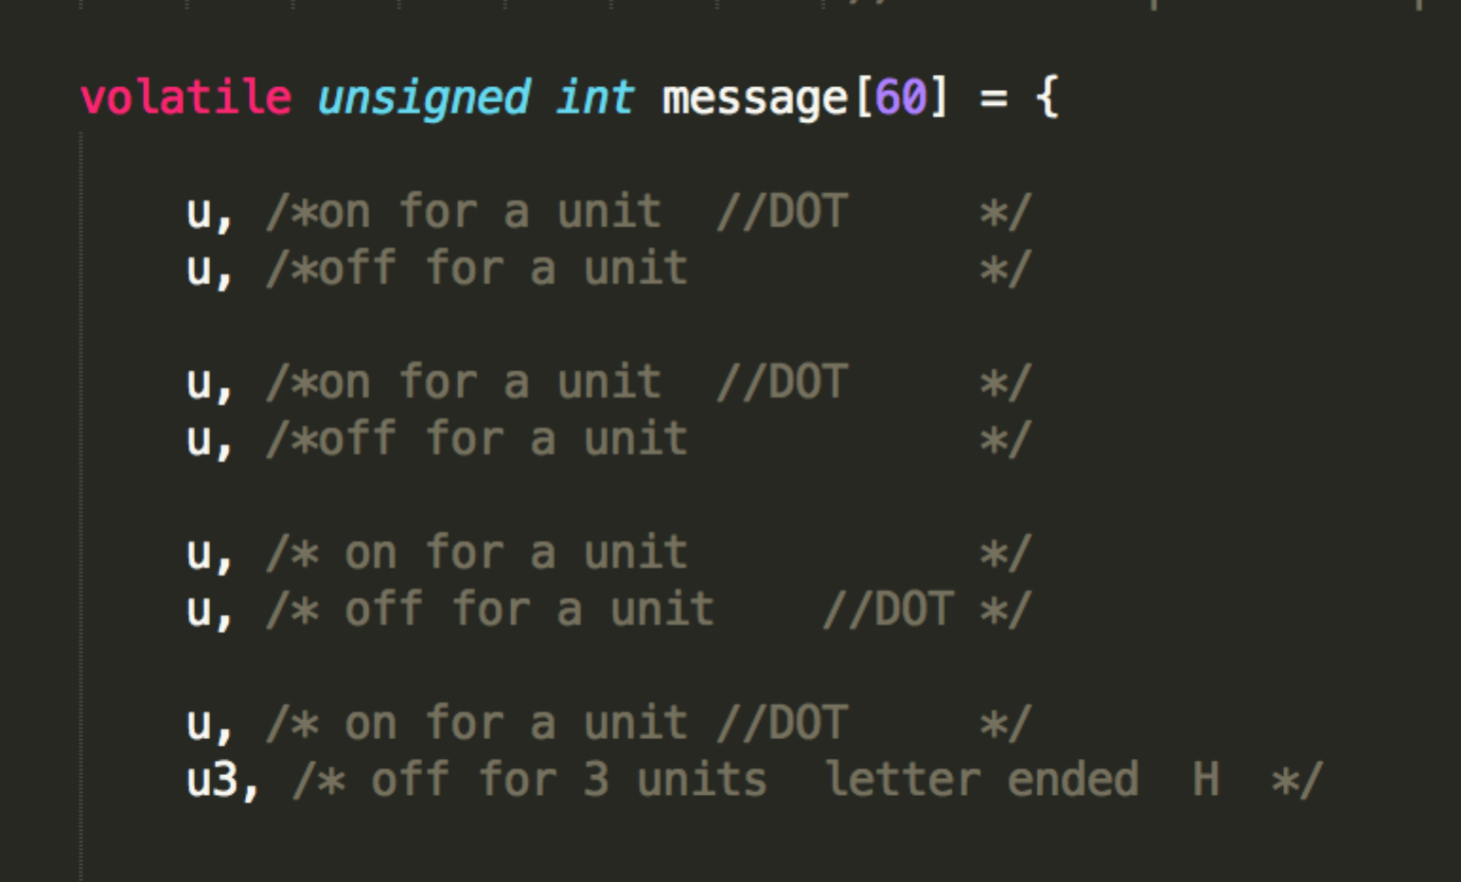

Like so, (more information can be seen in the code).

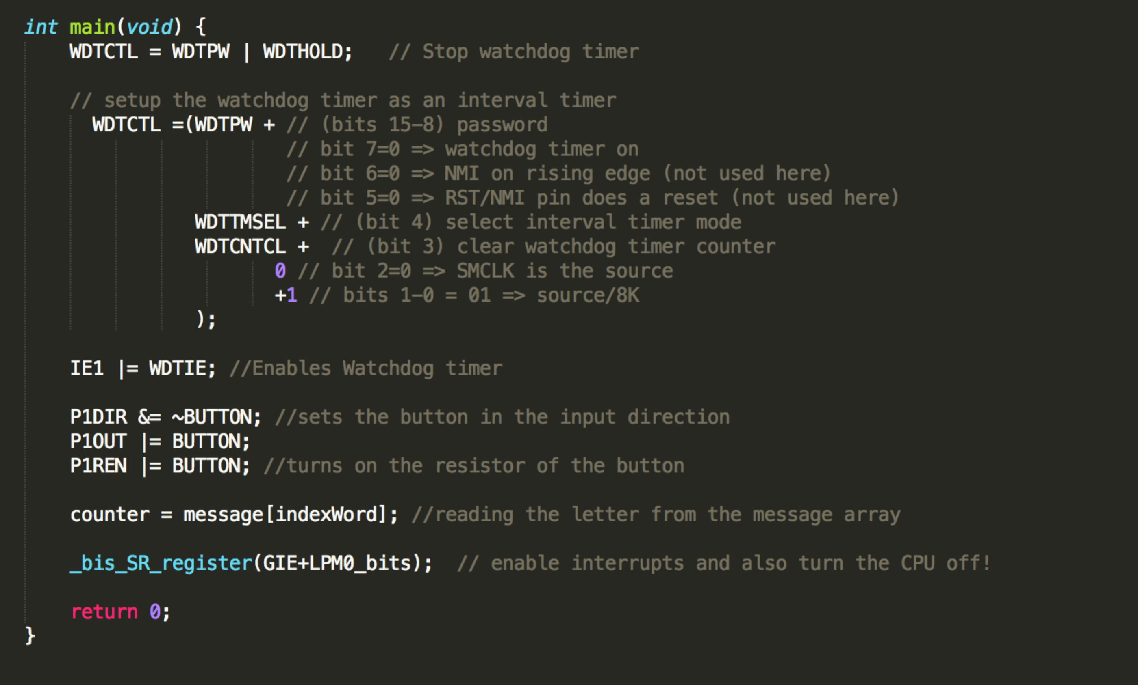

In my main function I enable the button as an input, I drove an output value of 1 to the button to know what the value was. Then I drove a 1 to the pin in the P1REN register to enable the pullup resistor on the board so that when pressed the button will have a value of 0 when pushed (pulled up to Vcc if not pressed) . Then I make my global variable ‘counter’ the current time delay of my array. The delays come in three flavors, there is u, u3, and u7. U is the base unit and is 30 and the other ones are u times three and u times 7. All together my delays are 30-90-210. Finally I enable the interrupt for the watchdog timer in the IE1 register. This lets the watchdog timer interrupt be able to be called. Finall, I go into a low power mode and enable interrupts so that my interrupt code can take over everytime the watchdog timer wakes up.

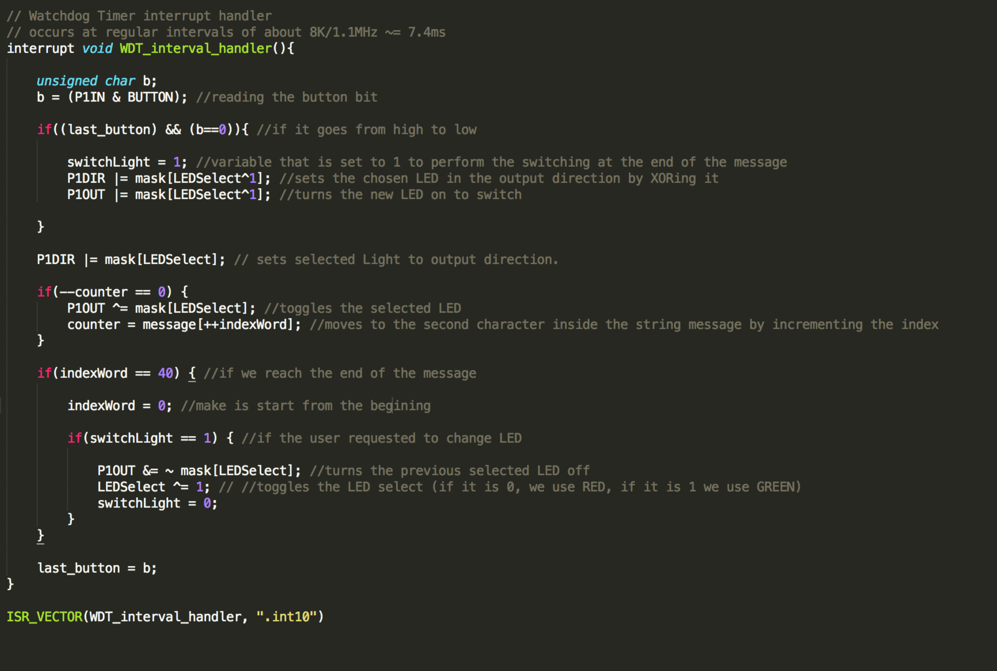

in the actual interrupt code. I register the function WDT_interval_handler as the function pointer to call when the interrupt in the 10th register gets called.

Finally inside the code above, I advance through my message array and work out delays and pin settings so that when the button is pressed the button can readily reply to the input. The specifics of the code can be seen above and in my main.c file attached.